**Project: Double Pendulum in Vpython**

**Made by: Muhammad Umer**

**Roll no. 20K-0225**

**Assigned by: Sir Waqar Ahmed**

**Problem Statement:**

Simulate a Double pendulum and demonstrate chaotic motion for the farthest end

of pendulum.

**Solution:**

Simulation of a double pendulum, for large motions, is a chaotic system, but for small motions it is a simple linear system.

You can change parameters in the simulation such as mass, gravity, and length of rods. You can drag the pendulum with your mouse to change the starting position.

When the angles are small in the Double Pendulum, the system behaves like the linear [Double Spring](https://www.myphysicslab.com/springs/double-spring-en.html). Motion is determined by simple sine and cosine functions. For large angles, the pendulum is non-linear. We regard the pendulum rods as being massless and rigid. We regard the pendulum masses as being point masses.

In simulation, the viewer will be able to observe change in motion of the both pendulums by time.

**Procedure:**

Objects in simulation:

1. Sphere of suitable radius, named ball, as our object of motion.

2. Ropes to hold the balls.

3. Stand to hold the ropes.

4. Axes and origin will be represented by curve and a sphere

Variables:

1. Gravitational field strength ‘g’
2. Mass of ball 1 ‘Mass1’
3. Mass of ball 2 ‘Mass2’
4. Diameter of balls ‘d’
5. Gap between balls ‘gap’
6. Length of ball 1 ‘Len1’
7. Length of ball 2 ‘Len2’
8. Radius of ball 1 ‘R1’
9. Radius of ball 2 ‘R2’

Initial values:

We will set the initial value of simulation height and width to 1000

Background color in vector form as vec(0,0,0) which is black

**Code Block:**

The following code was used to carry out the simulation results shown in results below.

scene.height = scene.width = 1000

scene.background = vec(0,0,0)

g = 9.8

Mass1 = 2

Mass2 = 1

d = 0.05

gap = 2*d

Len1 = 0.5

Len1display = Len1+d

Len2 = 1

Len2display = Len2+d/2

I1 = Mass1*Len1**2/12

I2 = Mass2*Len2**2/12

R1 = Len1/2

R2 = Len2/2-d/4

hpedestal = 1.3*(Len1+Len2)

wpedestal = 0.1

tbase = 0.05

wbase = 8*gap

offset = 2*gap

topofbar = vector(0,0,0)

scene.center = topofbar-vector(0,Len1,0)

pedestal = box(pos=topofbar-vector(0,hpedestal/2,0), height=1.1*hpedestal, length=wpedestal, width=wpedestal, color=vector(0.4,0.2,0.6))

base = box(pos=topofbar-vector(0,hpedestal+tbase/2,0), height=tbase, length=wbase, width=wbase, color=pedestal.color)

axle = cylinder(pos=topofbar-vector(0,0,offset-gap/2+d/5), axis=vector(0,0,2*(offset-gap/2+d/5)), radius=d/4, color=color.yellow)

class pendulum:

def __init__(self, pos=topofbar, theta1=1, theta1dot=0, theta2=0, theta2dot=0):

self.pos = pos

self.initial_theta1 = theta1

self.initial_theta1dot = theta1dot

self.initial_theta2 = theta2

self.initial_theta2dot = theta2dot

b1 = box(pos=pos+vector(R1,0,-(gap+d)/2), size=vector(Len1display,d,d), color=color.red)

b2 = box(pos=pos+vector(R1,0,(gap+d)/2), size=vector(Len1display,d,d), color=color.red)

c = cylinder(pos=pos+vector(Len1,0,-(gap+d)/2), axis=vector(0,0,gap+d), radius=axle.radius, color=color.green)

self.frame1 = compound([b1,b2,c])

self.frame1.rotate(angle=self.initial_theta1-pi/2, axis=vector(0,0,1), origin=vector(0,0,0))

self.frame1.initial_pos = vector(self.frame1.pos)

self.frame1.initial_axis = vector(self.frame1.axis)

b3 = box(pos=vector(R2,0,0), size=vector(Len2display,d,d), color=color.green)

self.frame2 = compound([b3])

self.reset()

self.__visible = True

def update(self, dtheta1=0, dtheta2=0):

self.theta1 += dtheta1

self.theta2 += dtheta2

self.frame1.rotate(angle=dtheta1, axis=vector(0,0,1), origin=self.pos)

axle2pos = self.frame1.pos+R1*norm(self.frame1.axis)

self.frame2.rotate(angle=dtheta2, axis=vector(0,0,1), origin=axle2pos)

self.frame2.pos = axle2pos+R2*norm(self.frame2.axis)

def reset(self):

self.theta1 = self.initial_theta1

self.theta1dot = self.initial_theta1dot

self.theta2 = self.initial_theta2

self.theta2dot = self.initial_theta2dot

self.frame1.pos = self.frame1.initial_pos

self.frame1.axis = self.frame1.initial_axis

axle2pos = self.frame1.pos+R1*norm(self.frame1.axis)

self.frame2.pos = axle2pos+vector(R2,0,0)

self.frame2.axis = vector(Len2display,0,0)

self.frame2.rotate(angle=self.theta2-pi/2, axis=vector(0,0,1), origin=axle2pos)

def get_visible(self):

return self.__visible

def set_visible(self, vis):

self.__visible = self.frame1.visible = self.frame2.visible = vis

pend1 = pendulum(topofbar+vector(0,0,offset), 2.1, 0, 2.4, 0)

pend2 = pendulum(topofbar+vector(0,0,-offset), 2.1, 0, 2.4, 0)

pend2.initial_theta1 += 0.001

pend2.reset()

pend2.set_visible(False)

pendula = [pend1, pend2]

scene.autoscale = False

run = False

def reset():

global t, gd, energy_check

t = 0

ResetRunbutton()

for pend in pendula:

pend.reset()

if gd:

gd.delete()

gd = None

energy_check = False

EnergyCheck(None)

def ResetRunbutton():

global run

run = False

Runbutton.text = "Run"

def Runb(r):

global run

run = not run

if run:

r.text = "Pause"

else:

r.text = "Run"

Runbutton = button(text='Run', bind=Runb)

scene.append_to_caption(' ')

button(text='Reset', bind=reset)

scene.append_to_caption('\n\nChoose a situation: ')

options = ['One double pendulum', 'Two double pendula, starting with angles that differ by only 0.001 radian']

def choosependula(p):

if p.selected == options[0]:

if not pendula[1].get_visible(): return

pendula[1].set_visible(False)

else:

if pendula[1].get_visible(): return

pendula[1].set_visible(True)

reset()

setmenu = menu(choices=options, selected='One double pendulum', bind=choosependula)

scene.append_to_caption('\n \n')

energy_check = False

gd = None

gK = None

gU = None

gE = None

def EnergyCheck(ec):

global energy_check, graphing, gd, gK, gU, gE

energy_check = not energy_check

if energy_check:

if not gd:

gd = graph(width=scene.width, height=300, title='K is green, U is blue, E = K+U is red')

t = 0

gK = gcurve(color=color.green)

gU = gcurve(color=color.blue)

gE = gcurve(color=color.red)

checkbox(bind=EnergyCheck)

scene.append_to_caption(' Graph energy (for front pendulum)\n\n')

dt = 0.0002

t = 0

n = 0

C11 = (0.25*Mass1+Mass2)*Len1**2+I1

C22 = 0.25*Mass2*Len2**2+I2

while True:

rate(1/dt)

if not run: continue

for pend in pendula:

C12 = C21 = 0.5*Mass2*Len1*Len2*cos(pend.theta1-pend.theta2)

Cdet = C11*C22-C12*C21

a = .5*Mass2*Len1*Len2*sin(pend.theta1-pend.theta2)

A = -(.5*Mass1+Mass2)*g*Len1*sin(pend.theta1)-a*pend.theta2dot**2

B = -.5*Mass2*g*Len2*sin(pend.theta2)+a*pend.theta1dot**2

pend.atheta1 = (C22*A-C12*B)/Cdet

pend.atheta2 = (-C21*A+C11*B)/Cdet

pend.theta1dot += pend.atheta1*dt

pend.theta2dot += pend.atheta2*dt

dtheta1 = pend.theta1dot*dt

dtheta2 = pend.theta2dot*dt

pend.update(dtheta1, dtheta2)

t = t+dt

n += 1

if energy_check and n >= 100:

n = 0

K = .5*((.25*Mass1+Mass2)*Len1**2+I1)*pend1.theta1dot**2+.5*(.25*Mass2*Len2**2+I2)*pend1.theta2dot**2+\

.5*Mass2*Len1*Len2*cos(pend1.theta1-pend1.theta2)*pend1.theta1dot*pend1.theta2dot

U = -(.5*Mass1+Mass2)*g*Len1*cos(pend1.theta1)-.5*Mass2*g*Len2*cos(pend1.theta2)

gK.plot(pos=(t,K))

gU.plot(pos=(t,U))

gE.plot(pos=(t,K+U))

**Result:**

Figures below show the successful simulation of the said problem. Changing the masses of balls completely changes the motion of this double pendulum. Changing the length of rope also varies motion. The first figure shows the reset position.

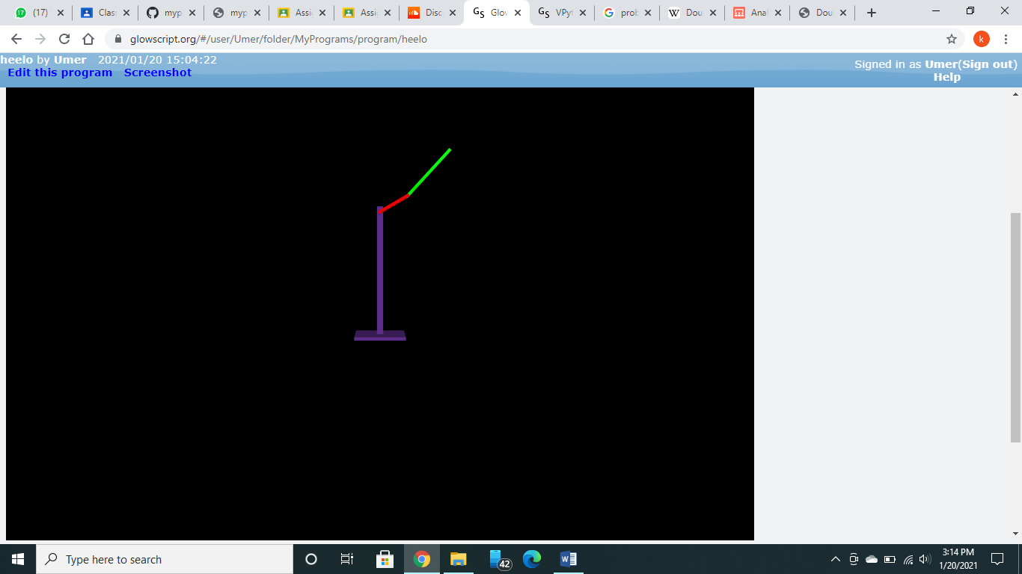

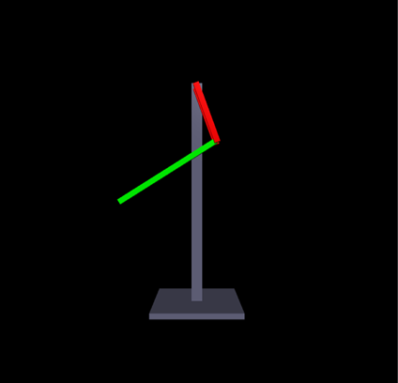

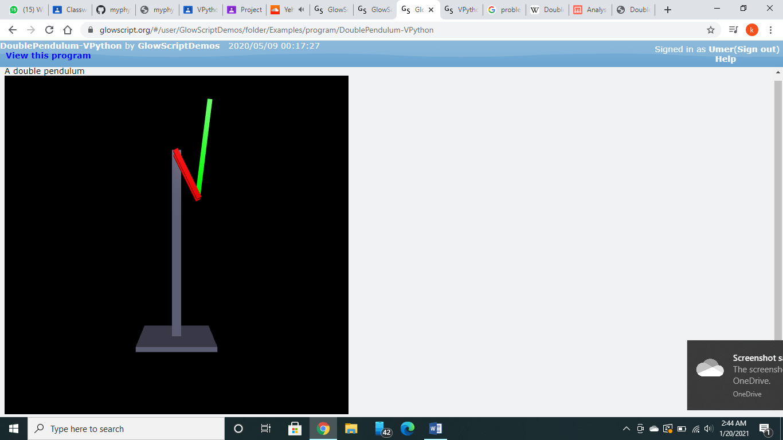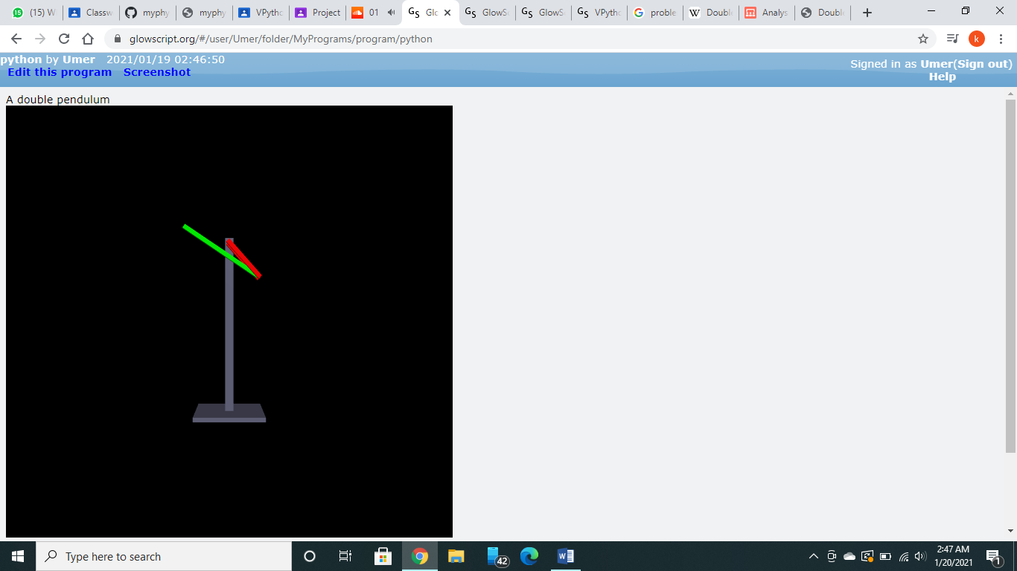

**Graphs:**

Graph of energy at the starting:

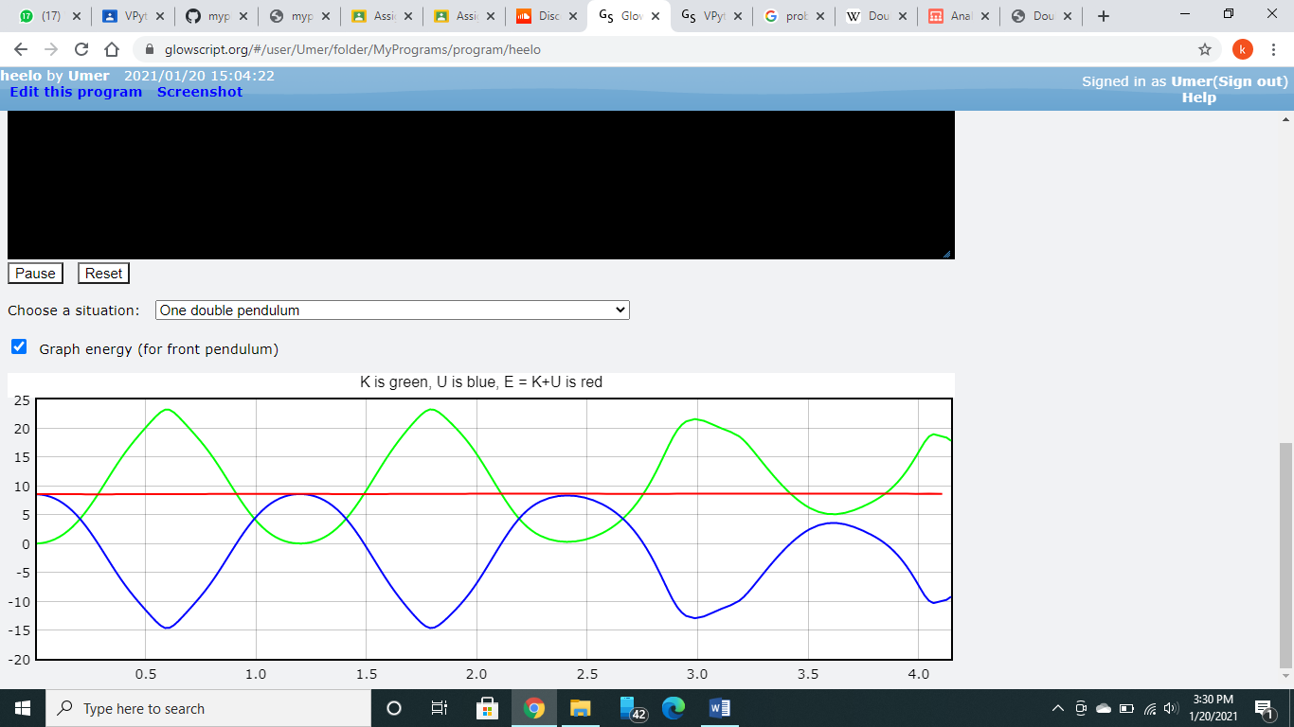

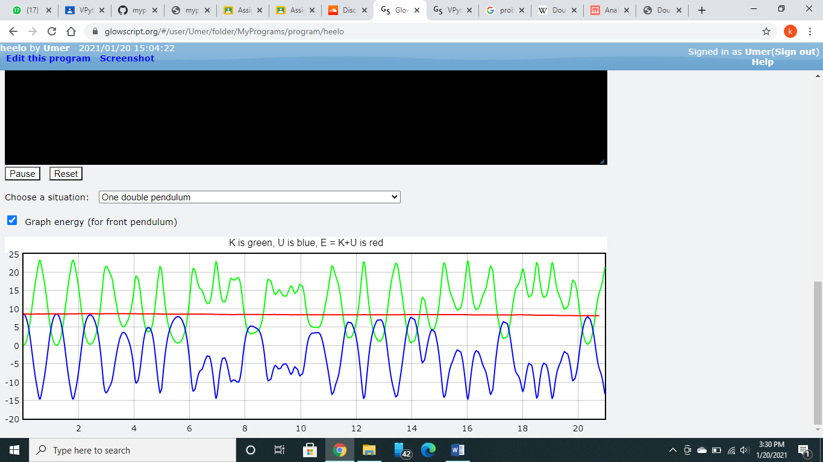Graph of energy after some time:

**Conclusion:**

We were easily able to demonstrate the motions of double pendulum with the help of Vpython with respect to time. This demonstration shows the chaotic motion of both balls with each other. We were able to conclude that the double pendulum was highly sensitive to initial starting conditions, as shown by the increasing difference between its angles and coordinate positions between a control and variations in initial velocities and angles.